sdmne.com  mail@sdmne.com  +375293230623 (Telegram, Viber, WhatsApp) | 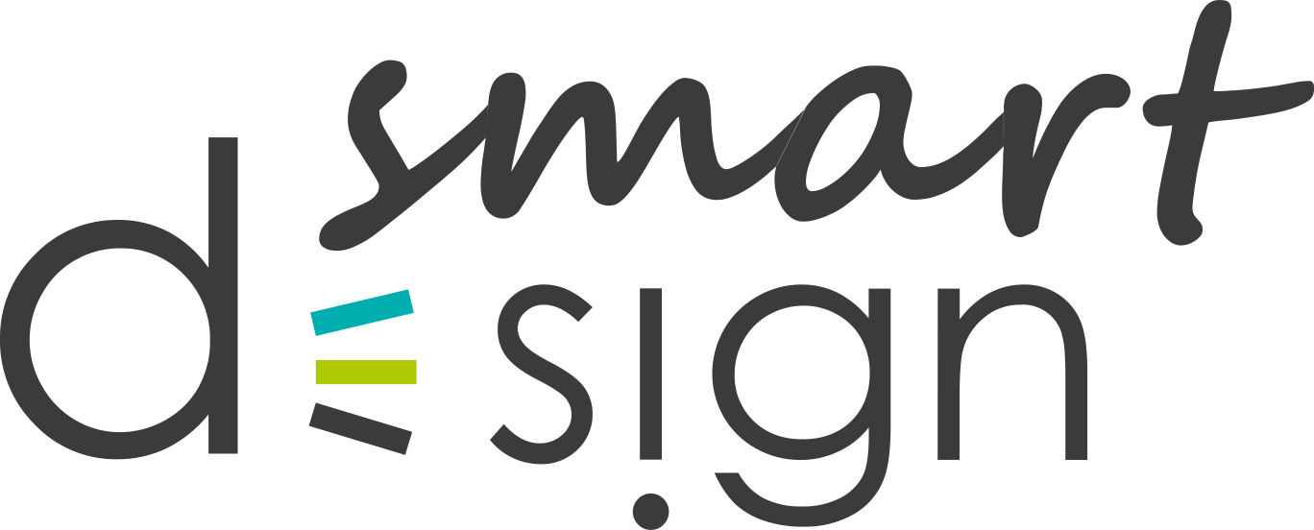

Mobile Application Development Brief
For a better understanding of your goals, we kindly ask you to fill out the questionnaire as detailed as possible. This will help us to quickly estimate the price and terms of implementation.

Date

Way of communication
Contact Person
Telephone / Skype
Email
Comfortable time for a call and your time zone

We guarantee complete confidentiality of the information provided about you and your activities.
If you are having difficulties completing the brief, please feel free to contact us in any way convenient for you. We will fill it together.

General
Project name. General concept.
Scope of the application (what does your company do?)
Objectives of the application. What do you want to achieve with the application?
How are you going to use the app? What tasks do you want to deliver?
The target audience. Who will use the application? What will be the conditions?
Similar projects that you like particularly. Why?

Functionality description
What should your application be able to do?
What features will be needed in your application?
Do you have any additions to this list?
What platform should the application run on? (if you have specific preferences)
Which side is the server on? Is API provided?

Timeline and budget
Desired and mandatory deadlines for the project
Estimated development budget. This will help us to offer you the best option and you can choose the appropriate application functionality.
If you have materials regarding the project (terms of reference, screen prototypes, design, etc.), please share a link with us (for example, Google Drive).

Your comments, questions, wishes
Thank you for working with us!

