sdmne.com  mail@sdmne.com  +375293230623 (Telegram, Viber, WhatsApp) | 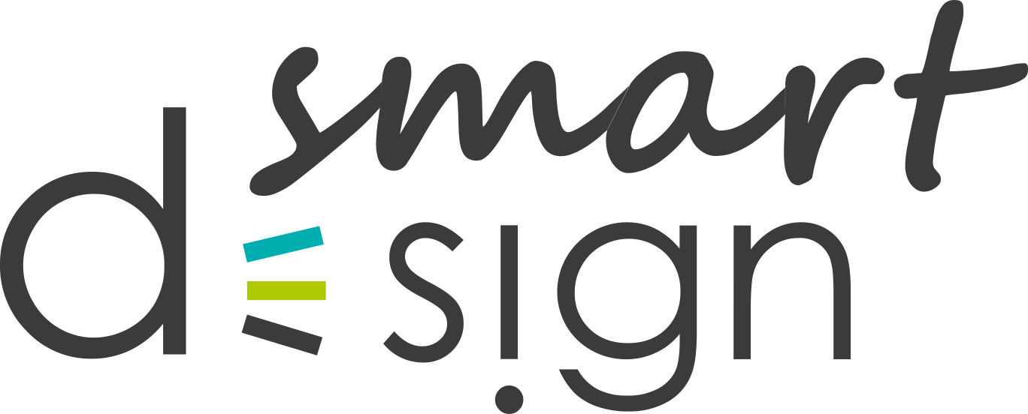

Logo Development Brief
For a better understanding of your goals, we kindly ask you to fill out the questionnaire as detailed as possible. This will help us to quickly estimate the price and terms of implementation.

Date

Way of communication
Contact Person
Telephone / Skype
Email
Comfortable time for a call and your time zone

We guarantee complete confidentiality of the information provided about you and your activities.
If you are having difficulties completing the brief, please feel free to contact us in any way convenient for you. We will fill it together.

Marketing component
Company’s sphere of interest
Business portfolio:
- Year of establishment
- Number of employees
- Advantages
- Sample of your goods or services
Target audience:
- Customers (retail)
- Companies (wholesale)
- Retail and wholesale
Age groups of typical customers:
- Under 18
- 18-25
- 25-40
- 40 and older
Brief of typical customers:
geographical – country, region, city.
demographic - gender.
psychographic – middle class, way of life, personality type, interests.
Positioning of company’s products or services:
Innovative, classic, other

What price range for services or products of the company:
Below average, average, above average, expensive.

Graphic Aspects
Concept:
What idea should an image of a logo contain?
The words that are most suitable for the style of the logo:
Example: strict, youth, avant-garde, graceful, soft, sports, voluminous, etc.
Color spectrum:
Colors desired or required. If yes, also indicate unwanted colors.
Graphic elements:
Graphic images that are desirable or required to use.
If there are undesirable elements, then also please indicate them.
Imagine the logo is a piece of music.
What genre do you attribute it to?
• Opera
• Classic
• Pop
• Rock
• Electronic

Technical Aspects
Name
What text content should be in the logo? Example: BestBuy, Sony
Interlineation
Slogan, site, field of activity (one for choice)
Example: online store, best products, amazon.com
Examples of logos you like
It might be not from the subject area. How did you evaluate?
Examples of logos that you do not like
It might be not from the subject area. How did you evaluate?
Logo language:
- English
- Dutch
- Other
Additional information:
Additional wishes for the logo

Budget and timeline
Estimated budget
Desired and mandatory deadlines

Please be advised that the brief serves as the basis for Terms of reference. Subsequently, deviations from the technical specifications, within the framework of special service packages, might not be possible.

We kindly ask you to provide us with sincere answers, as well as make clarifications if necessary.

If you don’t know what to answer, please leave a comment about it, for example "at your discretion".

Your comments, questions, wishes
Thank you for working with us!

